Air Quality Monitoring and Forecasting Services

(Air Quality Early Warning System)

**Introduction**

Air Quality Forecasts, if they are reliable and sufficiently accurate, can play an important role as part of an air quality management system The air quality (AQ) Forecast lets the public know expected air quality conditions for next 72 hours so that Government authorities can take action to manage the air quality and issue health advisories. Local air quality affects how you live and breathe. Like the weather, it can change from day to day or even hour to hour. The Graded Response Action Plan (GRAP) ensures that air pollution control actions are taken in Delhi-National Capital Region (NCR) based on the different air quality index categories namely, Moderate & Poor, Very Poor, and Severe as per National Air Quality Index. A new category of “Severe+ or Emergency” has also been added. The details of GRAP can be found at http://cpcbenvis.nic.in/pdf/final_graded_table.pdf. The meeting of task force is convened by CPCB periodically and more frequently during Severe and Severe+ AQI category. The task force, which includes officials from the different pollution control boards and experts, discusses the current air quality, the prediction ahead and the need for more proactive measures. The Air Quality forecast is highly important so that pollution control authorities can initiate action in advance. Head, EMRC attends the meeting as a representative of Director General of Meteorology. Generally, the meeting starts with the inputs presented by Head, EMRC and the discussion on weather and air quality prediction is considered of very high importance

**Air Quality Monitoring**

The methods of measurement prescribed by CPCB for respective parameters are the combination of physical method, wet-chemical method and continuous online method. The continuous online ambient air quality monitoring systems are equipped with analyzers for measurement of PM10, PM2.5, SO2, CO, NO2, O3, NH3 and Benzene. The metallic parameters Pb, Ni, As are measured offline using filter based air samplers. The ambient air quality monitoring station (AQMS) consists of following systems:

• PM10 & PM2.5: Operates on the principle of Beta Ray Attenuation and measures Particle Mass concentration ranging from 0 to 5 mg/m3 with Minimum detection limit 1 µg/m3 . The equipment includes a PM10 inlet and PM2.5 inlet.

• NOx and NH3: Operates on the principle of Chemiluminescence method, ranging from 0 to 2000µg/m3 with minimum detection limit 0.5µg/m3 .

• SO2 Analyser: Operates on the principle of UV Fluorescence method, ranging from 0 to 2000 µg/m3 with minimum detection limit 0.5 µg/m3

• CO Analyser: Operates on the principle of Non-Dispersive Infrared Spectrometry (NDIR) method, ranging from 0 to 100 mg/m3 with minimum detection limit 0.03 µg/m3

• O3 Analyser: Operates on the principle of UV Photometry method, range : 0 to 2500µg/m3 with minimum detection limit 0.5 µg/m3

• Benzene, Toluene, Ethylbenzene, Xylene (BTEX): GC/PID for automatic monitoring of BTEX in air with minimum detection level as low as 10 ppt in ambient air

• Multigas Calibrator: to calibrate gas analyzers manually, remotely controlled or automatically, for quality assurance. Multi Calibration upto 20 points.

• Automatic Weather Station (AWS): Ultrasonic Wind Sensor, Barometric Pressure, Temperature, Relative Humidity, Rainfall, Solar Radiation etc. All these instruments except AWS are housed in a room or walk-way shelter with proper sampling system for gaseous and particulate matter parameters. AQMS should have the calibration facility for onsite calibration with zero and standard gases. Beta Ray Attenuation for the measurement of PM10 and PM2.5 should be calibrated with standard filters. The detailed guideline for site selection, measurement frequency, reporting etc has been notified by CPCB. Each AQMS should also have a PC for recording and transmission of the data via internet

**Colour Coding for different AQ Index categories**

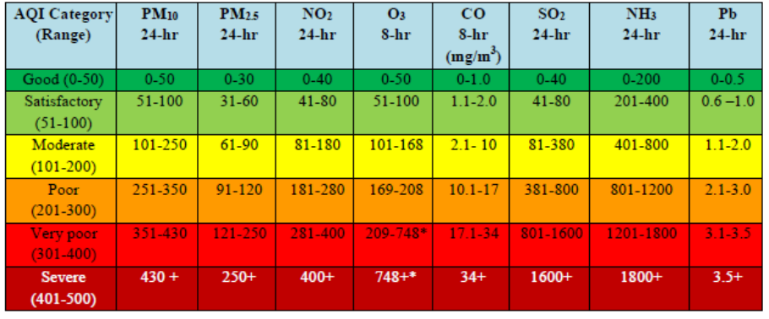

**Air Quality Prediction Models**

There are different Air Quality Prediction Models operationally run under the air quality early warning system (AQ-EWS)

1. Weather Research and Forecasting model coupled with chemistry (WRF-Chem)
2. System for Integrated modeLling of Atmospheric composition (SILAM)
3. High resolution model ENvironmental information FUsion SERvice (ENFUSER)
4. NCMRWF Unified Model (NCUM) Dust-Forecast

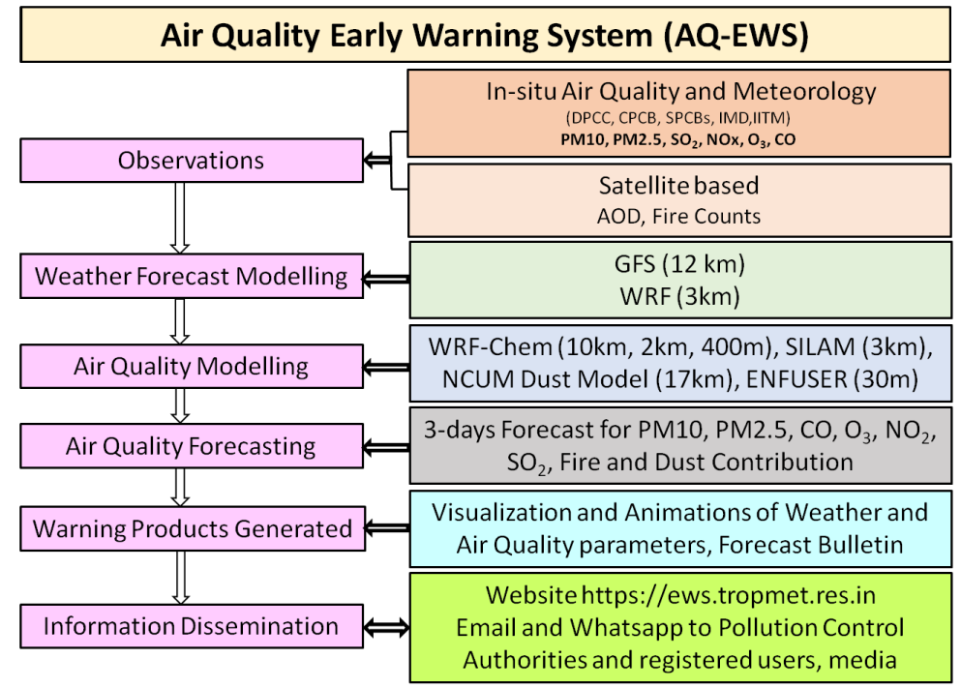 **General Schematic of the Air Quality EarlyWarning SYSTEM**

**Project Design**

The development of this system via XAMPP platform allows the air quality level in parts per million (ppm) data to be stored in an online database, thus allowing the public to continuously monitor the air quality level and avoid themselves to be exposed rapidly to these harmful gases. The developed hardware system consists of the MQ135 gas sensor. The gas sensor is able to sense the present of gases through the chemical reaction when the gases flows close to the sensor. The reading of air quality level appears on an I2C LCD

* **Figure 1** shows the block diagram of project design. There are two mains part of the design which are hardware design and software design.
* **Figure 2** shows the flowchart of the hardware design and software design.

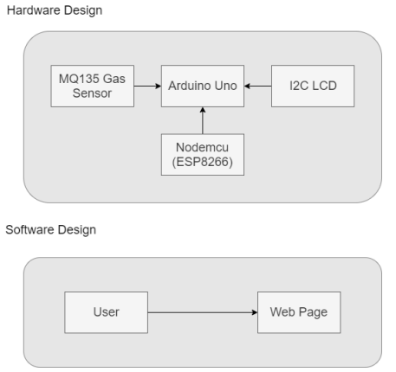

**Hardware Development**

A few of suitable components with high performance were used for hardware development. All of the components were at a reasonable cost to integrate to the web server platform of air quality monitoring system.

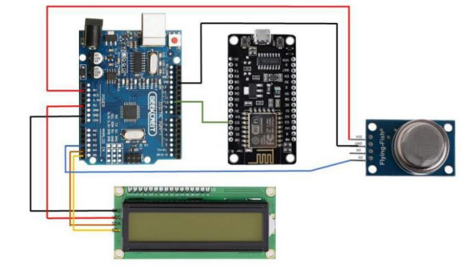

**Software Development**

The software implemented and programmed for this project include the Arduino Software IDE which allows the Arduino program to be uploaded to the Arduino board, as well as the XAMPP online platform which allows users to monitor data on a web page interface. The Arduino Software IDE is used for writing of the Arduino programming language or code whereby the program can be uploaded to the Arduino board via the Atmega8U2 chip and USB connection to the computer. This allows the board to perform the functions specified in the program, by which the output data or results of this particular program were displayed in the Serial Monitor feature that is incorporated in the Arduino software. Arduino is an easy tool for fast prototyping which allows the development of projects that are fully-functional at a low cost. Arduino board can apply and adapt to various needs and challenges differentiating its offer from simple 8-bit boards

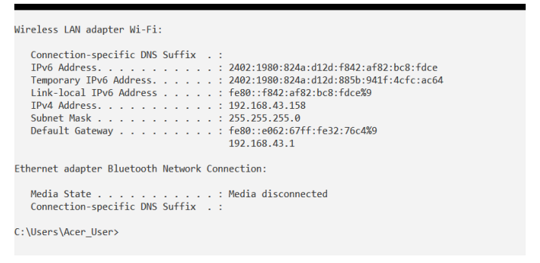

Figure: **Command Prompt (CMD) windows displaying the IP address**

**Results**

The web page interfaces for this system were developed in the Notepad ++ source code editor, with the coding written in Hypertext Preprocessor (PHP) programming language and linked directly to the SQLyog database. The page allows the user to log into the system in order to monitor air quality level in a real time since the data were sent into the web page for every ten second through the database system as shown